NAME:PRERNA KUMARI

In [2]:

**import** pandas **as** pd

**import** numpy **as** np

**import** matplotlib.pyplot **as** plt

**import** seaborn **as** sns

In [10]:

sns.get_dataset_names()

Out[10]: ['anagrams',

'anscombe', 'attention',

'brain_networks', 'car_crashes',

'diamonds', 'dots',

'dowjones', 'exercise', 'flights', 'fmri',

'geyser',

'glue',

'healthexp', 'iris',

'mpg',

'penguins', 'planets', 'seaice',

'taxis',

'tips',

'titanic']

In [4]:

dataset**=** sns.load_dataset('car_crashes')

In [14]:

dataset.head()

Out[14]:

|  |  |  |  |  |  |  |  |
| --- | --- | --- | --- | --- | --- | --- | --- |
| **total** | **speeding** | **alcohol** | **not_distracted** | **no_previous** | **ins_premium** | **ins_losses** | **abbrev** |
| **0** 18.8 | 7.332 | 5.640 | 18.048 | 15.040 | 784.55 | 145.08 | AL |
| **1** 18.1 | 7.421 | 4.525 | 16.290 | 17.014 | 1053.48 | 133.93 | AK |
| **2** 18.6 | 6.510 | 5.208 | 15.624 | 17.856 | 899.47 | 110.35 | AZ |
| **3** 22.4 | 4.032 | 5.824 | 21.056 | 21.280 | 827.34 | 142.39 | AR |
| **4** 12.0 | 4.200 | 3.360 | 10.920 | 10.680 | 878.41 | 165.63 | CA |

In [15]:

*#getting the information of the dataset*

dataset.info()

<class 'pandas.core.frame.DataFrame'> RangeIndex: 51 entries, 0 to 50

Data columns (total 8 columns):

# Column Non-Null Count Dtype

|  |  |  |  |  |  |  |
| --- | --- | --- | --- | --- | --- | --- |
| 0 |  | total | 51 | non-null |  | float64 |
| 1 |  | speeding | 51 | non-null |  | float64 |
| 2 |  | alcohol | 51 | non-null |  | float64 |
| 3 |  | not_distracted | 51 | non-null |  | float64 |
| 4 |  | no_previous | 51 | non-null |  | float64 |
| 5 |  | ins_premium | 51 | non-null |  | float64 |
| 6 |  | ins_losses | 51 | non-null |  | float64 |
| 7 |  | abbrev | 51 | non-null |  | object |

dtypes: float64(7), object(1) memory usage: 3.3+ KB

In [16]:

*#getting the shape*

dataset.shape

Out[16]: (51, 8)

In [20]:

*# plotting lineplot*

sns.lineplot(data**=**dataset, y**=**'total', x**=**'speeding')

C:\Users\hp\AppData\Local\Programs\Python\Python310\lib\site-packages\seaborn

\_oldcore.py:1498: FutureWarning: is_categorical_dtype is deprecated and will be removed in a future version. Use isinstance(dtype, CategoricalDtype) inste ad

if pd.api.types.is_categorical_dtype(vector):

C:\Users\hp\AppData\Local\Programs\Python\Python310\lib\site-packages\seaborn

\_oldcore.py:1498: FutureWarning: is_categorical_dtype is deprecated and will be removed in a future version. Use isinstance(dtype, CategoricalDtype) inste ad

if pd.api.types.is_categorical_dtype(vector):

C:\Users\hp\AppData\Local\Programs\Python\Python310\lib\site-packages\seaborn

\_oldcore.py:1119: FutureWarning: use_inf_as_na option is deprecated and will be removed in a future version. Convert inf values to NaN before operating in stead.

with pd.option_context('mode.use_inf_as_na', True):

C:\Users\hp\AppData\Local\Programs\Python\Python310\lib\site-packages\seaborn

\_oldcore.py:1119: FutureWarning: use_inf_as_na option is deprecated and will be removed in a future version. Convert inf values to NaN before operating in stead.

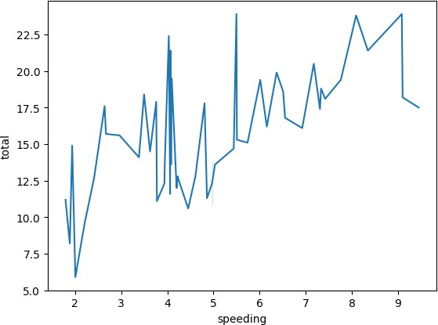with pd.option_context('mode.use_inf_as_na', True): Out[20]: <AxesSubplot: xlabel='speeding', ylabel='total'>

Inference: · total -> Number of drivers involved in fatal collisions per billion miles (5.900–23.900) speeding -> Percentage Of Drivers Involved In Fatal Collisions Who Were Speeding (1.792– 9.450)

this is a line plot between the speeding dircvers and total no of drivers involved in collosion we can clearly see that as speeding increases the no.of collesions increases drastically

In [10]:

*#scatter plot*

plt.figure(figsize**=**(5, 3))

sns.scatterplot(data**=**dataset, y**=**'total', x**=**'alcohol') plt.show()

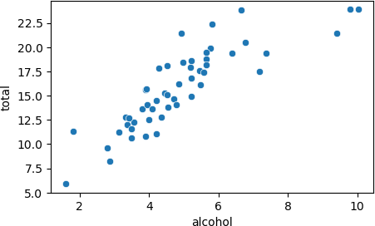

In [ ]:





Inference:

The scatter plot of the 'total' **and** 'alcohol' columns **in** the car_crashes d reveals a positive correlation between these variables.

This suggests that **as** the total number of car crashes increases, there ten be a corresponding rise **in** the number of incidents involving alcohol. Howe it's important to note that while this correlation exists, it doesn't simp causation. Other factors may contribute to this relationship, **and** further analysis would be needed to establish any causal links. Additionally,

the presence of a few outliers indicates that there are instances where th number of alcohol**-**related incidents deviates significantly **from** the genera This scatter plot provides a valuable visual representation of the relatio offering insights into potential areas of concern **for** traffic safety **and** a

In [30]:

*#dist plot*

sns.distplot(dataset['total'])

C:\Users\hp\AppData\Local\Temp\ipykernel_17484\2994018954.py:2: UserWarning:

`distplot` is a deprecated function and will be removed in seaborn v0.14.0.

Please adapt your code to use either `displot` (a figure-level function with similar flexibility) or `histplot` (an axes-level function for histograms).

For a guide to updating your code to use the new functions, please see

[https://gist.github.com/mwaskom/de44147ed2974457ad6372750bbe5751 (https://gis t.github.com/mwaskom/de44147ed2974457ad6372750bbe5751)](https://gist.github.com/mwaskom/de44147ed2974457ad6372750bbe5751)

sns.distplot(dataset['total'])

C:\Users\hp\AppData\Local\Programs\Python\Python310\lib\site-packages\seaborn

\_oldcore.py:1498: FutureWarning: is_categorical_dtype is deprecated and will be removed in a future version. Use isinstance(dtype, CategoricalDtype) inste ad

if pd.api.types.is_categorical_dtype(vector):

C:\Users\hp\AppData\Local\Programs\Python\Python310\lib\site-packages\seaborn

\_oldcore.py:1119: FutureWarning: use_inf_as_na option is deprecated and will be removed in a future version. Convert inf values to NaN before operating in stead.

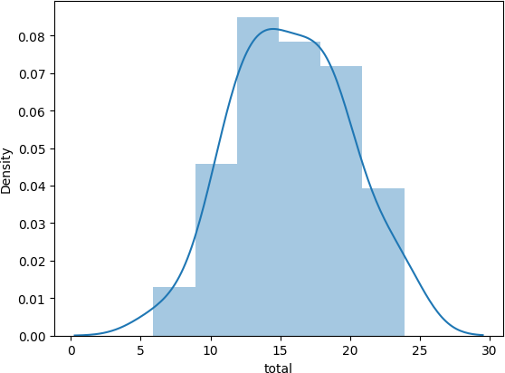with pd.option_context('mode.use_inf_as_na', True): Out[30]: <AxesSubplot: xlabel='total', ylabel='Density'>

In [ ]:





Inference:

This plot illustrates the distribution of total car crashes. It appears to be indicating that there are more instances of lower crash counts. The majority o suggesting that most areas experience a relatively low number of car crashes. counts, which are represented by the tail on the right side of the distributio the frequency **and** severity of car accidents **in** the dataset.

In [9]:

*#bar plot*

res **=** sns.barplot(x **=**'abbrev' , y**=**'alcohol', data**=**dataset , palette**=**"rocket" ) plt.show()

C:\Users\hp\AppData\Local\Programs\Python\Python310\lib\site-packages\seaborn

\_oldcore.py:1498: FutureWarning: is_categorical_dtype is deprecated and will be removed in a future version. Use isinstance(dtype, CategoricalDtype) inste ad

if pd.api.types.is_categorical_dtype(vector):

C:\Users\hp\AppData\Local\Programs\Python\Python310\lib\site-packages\seaborn

\_oldcore.py:1498: FutureWarning: is_categorical_dtype is deprecated and will be removed in a future version. Use isinstance(dtype, CategoricalDtype) inste ad

if pd.api.types.is_categorical_dtype(vector):

C:\Users\hp\AppData\Local\Programs\Python\Python310\lib\site-packages\seaborn

\_oldcore.py:1498: FutureWarning: is_categorical_dtype is deprecated and will be removed in a future version. Use isinstance(dtype, CategoricalDtype) inste ad

if pd.api.types.is_categorical_dtype(vector):

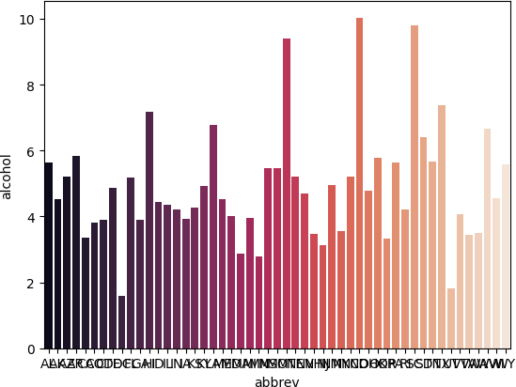

In [ ]:





inference:

This bar plot displays the average alcohol involvement **in** car crashes **for** The vertical bars provide a visual comparison of the alcohol**-**related incid From the plot, it can be observed that some regions have notably higher av This information can be crucial **for** identifying areas where stricter measu the risks associated **with** alcohol**-**related accidents.

In [18]:

*#countplot*

sns.countplot(x**=**'total', data **=** dataset)

C:\Users\hp\AppData\Local\Programs\Python\Python310\lib\site-packages\seaborn

\_oldcore.py:1498: FutureWarning: is_categorical_dtype is deprecated and will be removed in a future version. Use isinstance(dtype, CategoricalDtype) inste ad

if pd.api.types.is_categorical_dtype(vector):

C:\Users\hp\AppData\Local\Programs\Python\Python310\lib\site-packages\seaborn

\_oldcore.py:1498: FutureWarning: is_categorical_dtype is deprecated and will be removed in a future version. Use isinstance(dtype, CategoricalDtype) inste ad

if pd.api.types.is_categorical_dtype(vector):

C:\Users\hp\AppData\Local\Programs\Python\Python310\lib\site-packages\seaborn

\_oldcore.py:1498: FutureWarning: is_categorical_dtype is deprecated and will be removed in a future version. Use isinstance(dtype, CategoricalDtype) inste ad

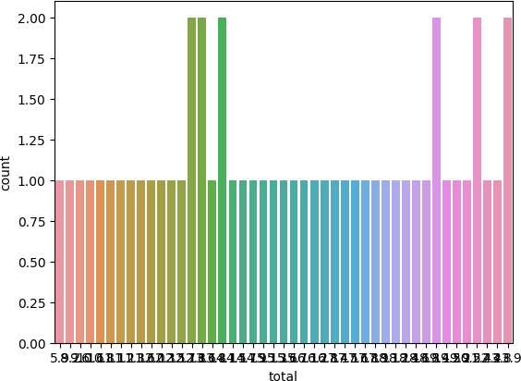if pd.api.types.is_categorical_dtype(vector): Out[18]: <AxesSubplot: xlabel='total', ylabel='count'>

inference: This count plot offers insight into the distribution of total car crash occurrences. It displays the frequency of different total crash counts in the dataset. From the plot, it can be observed that the majority of instances involve a relatively low number of car crashes. However, there are also instances of higher crash counts, although they are less frequent. This information is crucial for understanding the distribution and frequency of car accidents in the dataset, which may have implications for safety measures and policy decisions.

In [24]:

*#co-relation Heatmap*

numeric_data **=** dataset.select_dtypes(include**=**['float64', 'int64'])

sns.heatmap(numeric_data.corr(), cbar**=True**, annot**=True**, fmt**=**".2f", linewidths**=**

Out[24]: <AxesSubplot: >

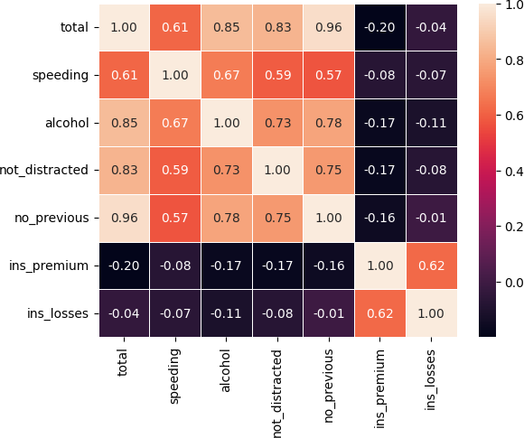

In [ ]:

inference:

here the lighter colors indicate that they are positively corealated i.e t are directly proportional , whereas the darker colors indicates that they corelated i.e they are inversly propotional.